# ABC Inventory Management

# Test Scenario: Beta Test Scenario 5

Table of Contents

ABC Inventory Management 1

Test Scenario: Beta Test Scenario 5 1

Scenario Description 3

Version Control 3

User Group 3

Test Log 3

Steps 3

Result Screenshots 4

# Scenario Description

This is the fifth Beta test scenario of ABC Inventory Management. The test was conducted by a third-party user to check if they could use the system as they wanted. No scripts were prepared so that the user had complete freedom to conduct any activity they wished for. All activities conducted by the user were logged when the user was conducting the tests. These logs were observed and documented in this document by the author. The basic information of the application and a user manual was provided to the user. The user was also given a warehouse staff password and a store staff password.

# Version Control

|  |  |  |  |
| --- | --- | --- | --- |
| Version Number | Date | Author | Description |
| 6.0 | 02/10/2018 | Shirish Maharjan | Initial Draft |
| 6.1 | 11/10/2018 | Shirish Maharjan | First Version (Iteration 6) |

# User Group

* Sarvesh Thapa

# Test Log

## Steps

|  |  |  |  |
| --- | --- | --- | --- |
| Step | Test Action | Expected Results | Pass/Fail |
| 1. | Application is launched. | System displays the ‘Login’ Page with the Username and Password field empty. | Pass |
| 2. | User enters the provided warehouse staff username and password. | System waits for user to click on ‘Login’ button. | Pass |
| 3. | User clicks on the ‘Login’ button. | System grants access to the user and opens the Homepage with Warehouse Staff access. | Pass |
| 4. | User clicks on ‘Generate Report’ button. | System displays the ‘Generate Report’ page. | Pass |
| 5. | User clicks on the ‘Homepage’ button. | System displays the Homepage. | Pass |
| 6. | User clicks on the ‘Logout’ button. | System displays a dialog box prompting the user to confirm the logout action. | Pass |
| 7. | User clicks on ‘Yes’. | User is logged out and the login page is displayed. | Pass |
| 8. | User enters the store staff login details. | System waits for user’s action. | Pass |
| 9. | User clicks on the ‘Login’ button. | System displays the homepage with store staff access. | Pass |
| 10. | User clicks on the ‘Accept Product’ button | System displays the accept product page. | Pass |
| 11. | User selects the detail button of the product transfer that needs to be accepted into the location. | System displays the content of the transfer. | Pass |
| 12. | User clicks on the ‘Accept’ button | System updates the database and displays an appropriate message. | Pass |
| 13. | User clicks on Ok in the message displayed. | System displays the refreshed accept product page. | Pass |

### Result Screenshots

**Step 1**

Application launched, and login page is displayed.

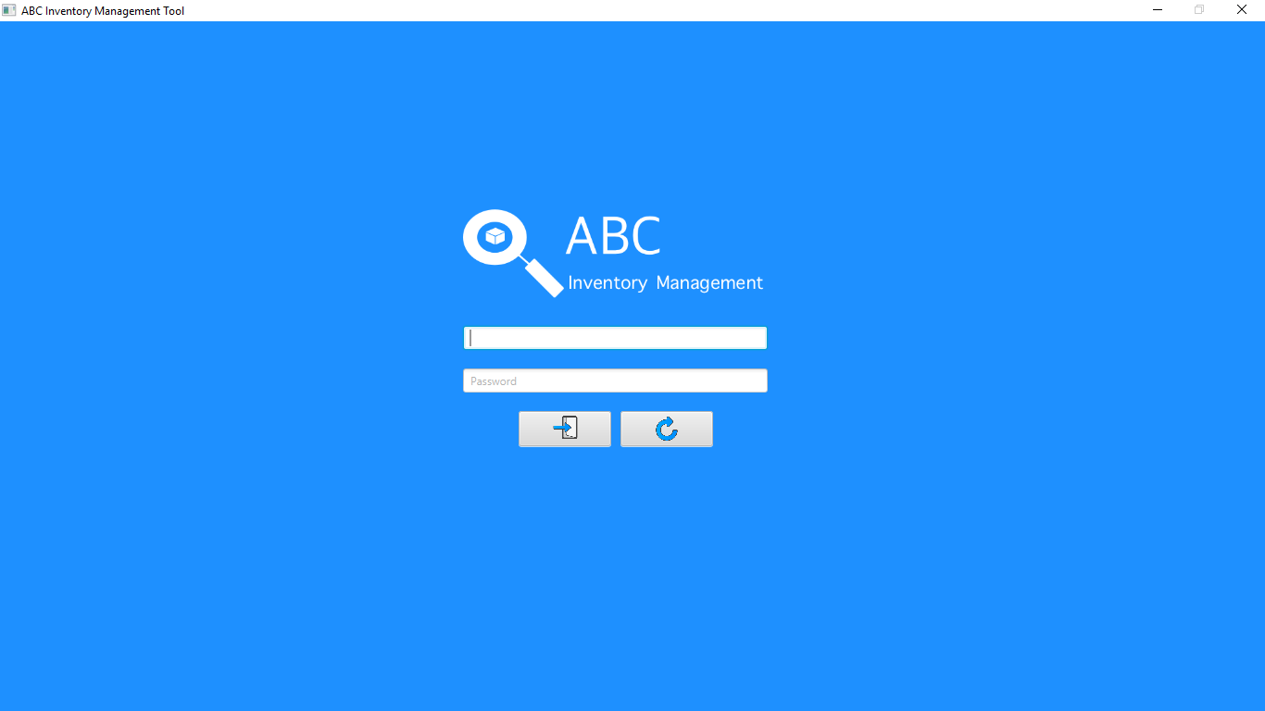

**Step 2**

Username and password are entered, and the system waits user to click on the ‘Login’ button.

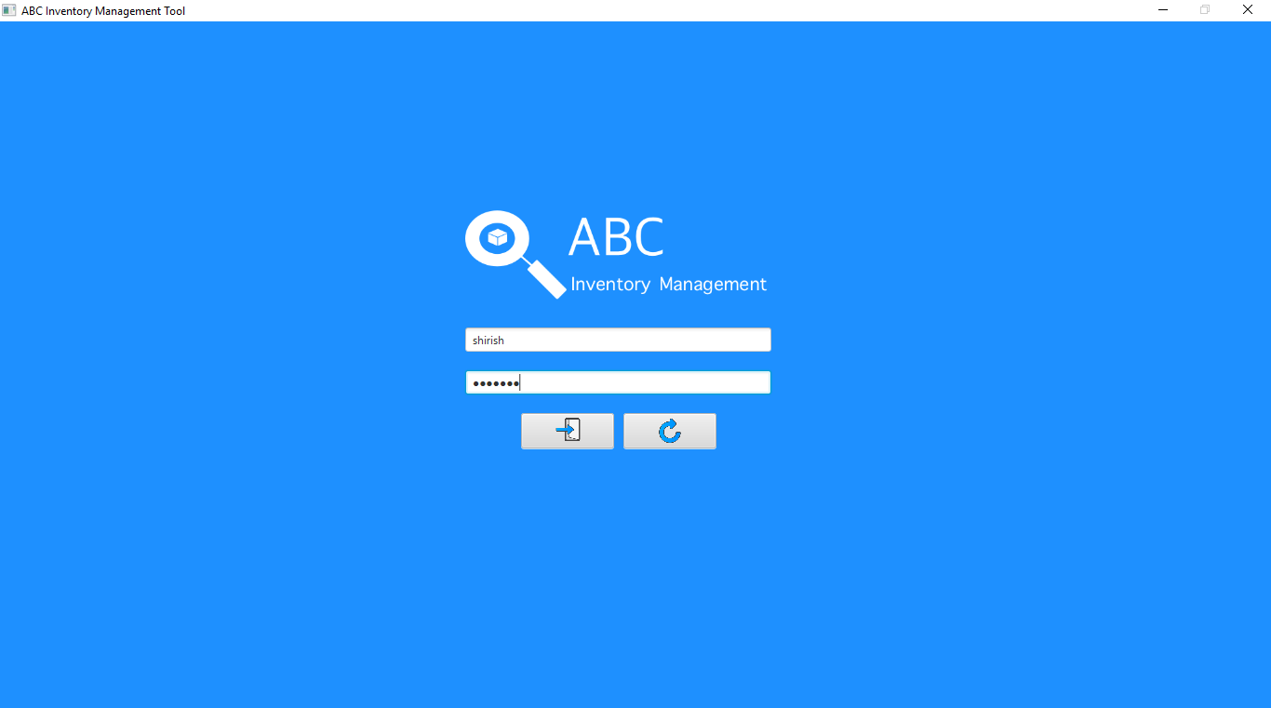

**Step 3**

After the user clicks on the login button, the homepage is displayed with warehouse staff access.

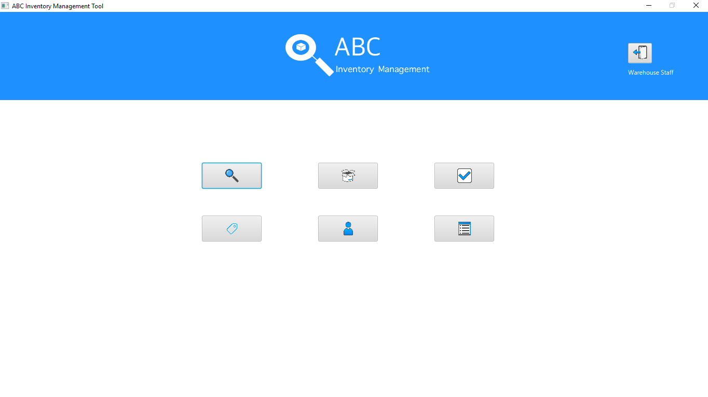

**Step 4**

When user clicks on the ‘Generate Report’ button, the generate report page is displayed.

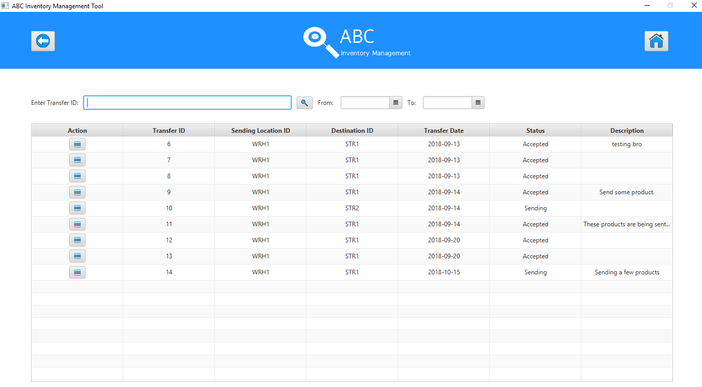

**Step 5**

When user clicks on the ‘Homepage’ button, the homepage is displayed.

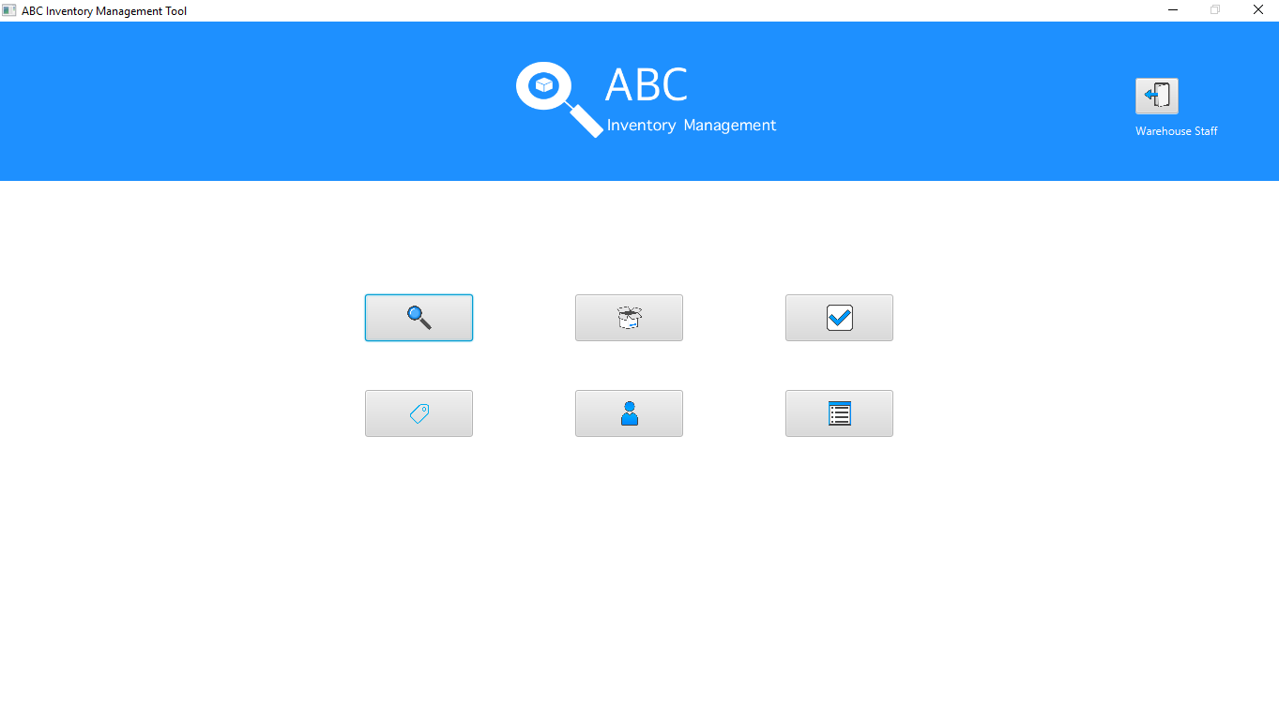

**Step 6**

When user clicks on the ‘Logout’ button, the system displays a dialog box prompting the user to confirm the logout action.

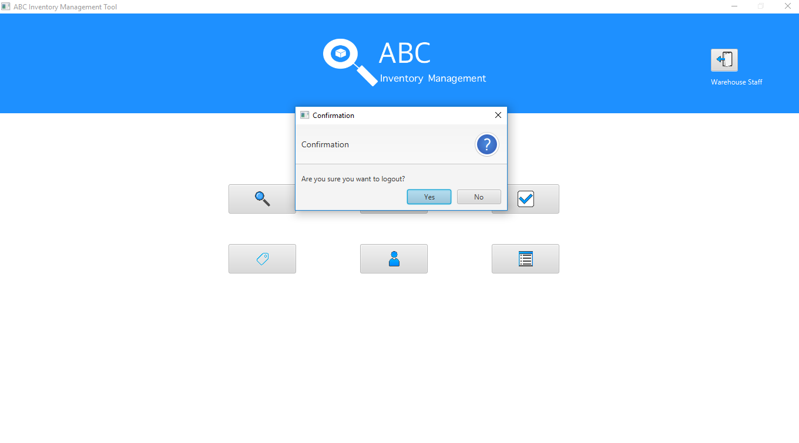

**Step 7**

When the user clicks on yes option, the user is logged out of the system and the login page is displayed.

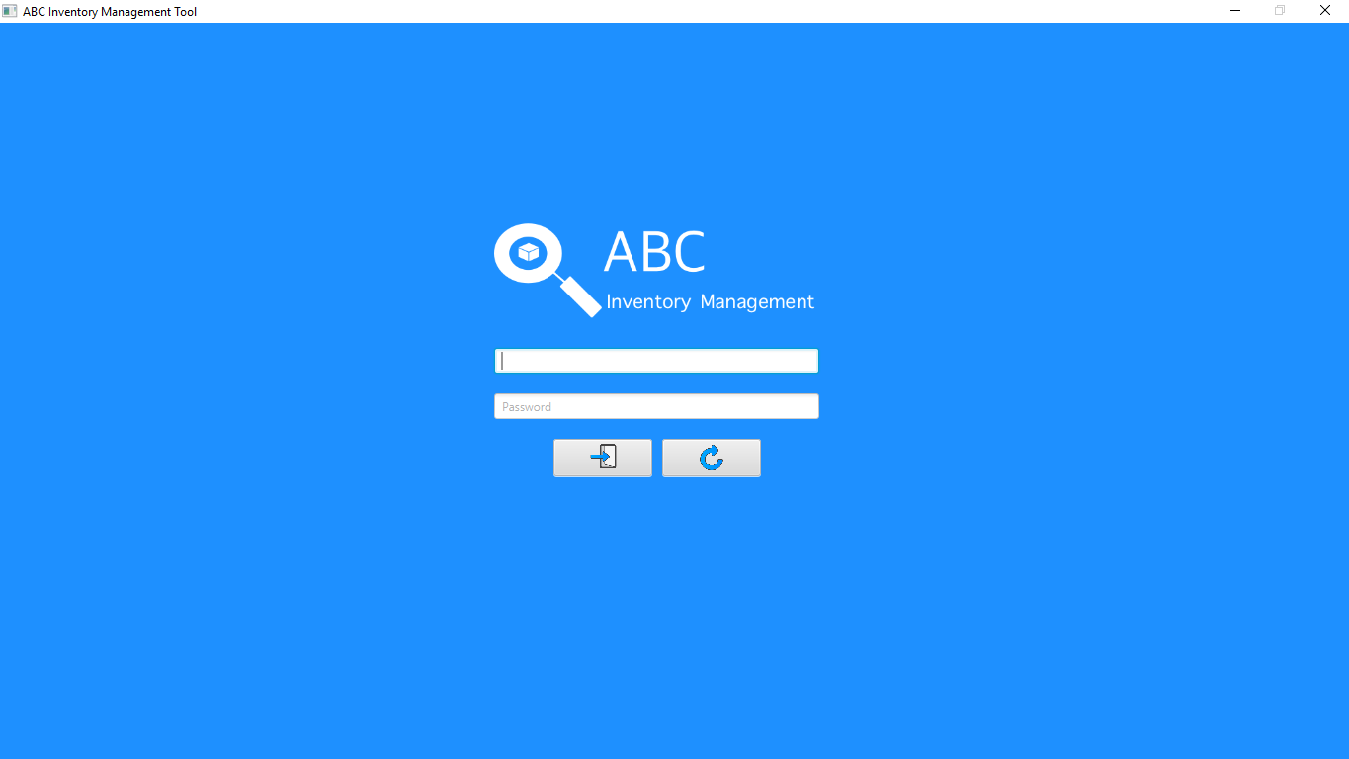

**Step 8**

The user enters the store staff login details.

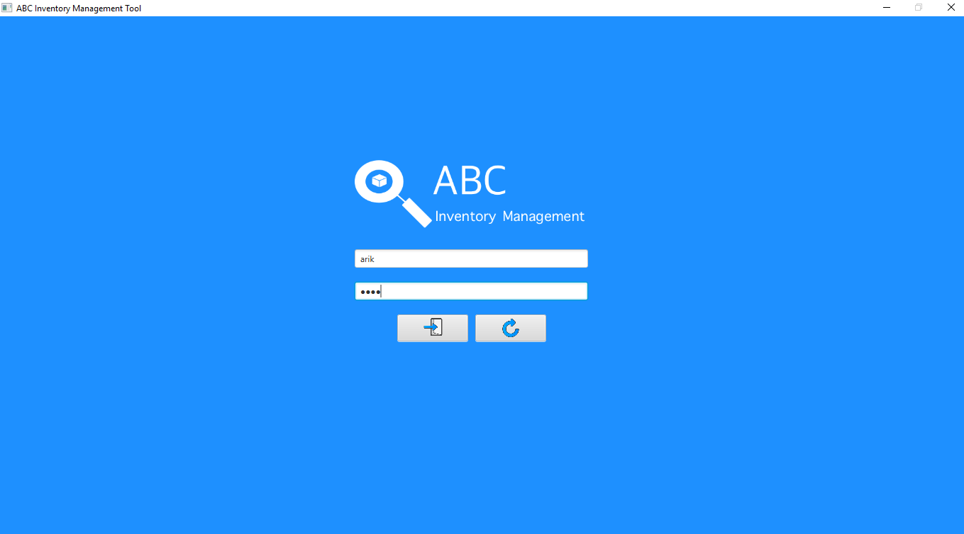

**Step 9**

The user clicks on the ‘Login Button’

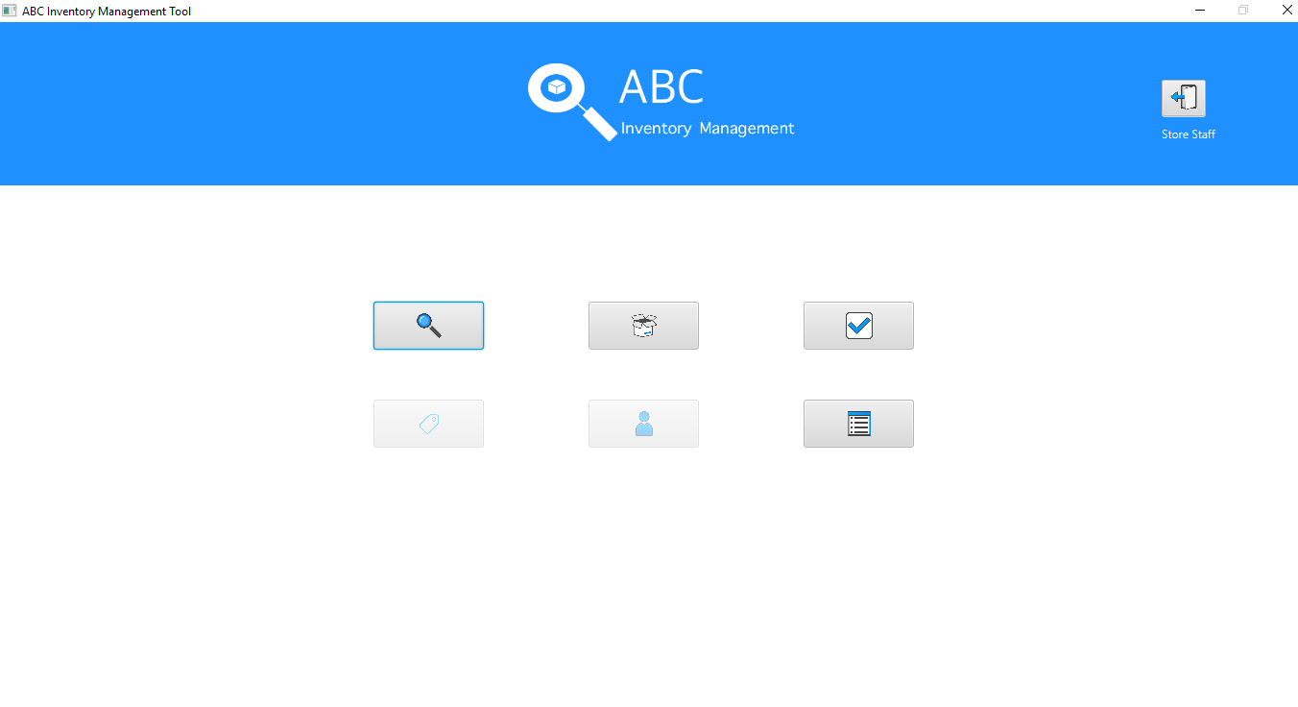

**Step 10**

After the user clicks on the ‘Accept Product’ button, the accept product page is displayed.

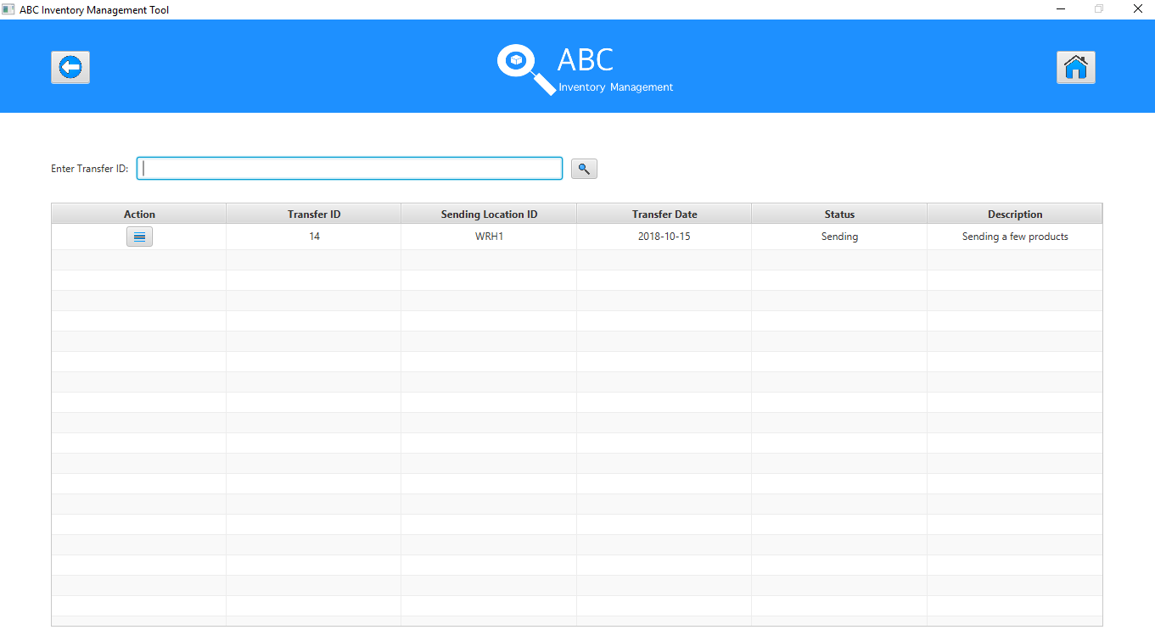

**Step 11**

After the user clicks on the ‘Detail’ button for the transfer that needs to be accepted, the contents of the transfer is displayed.

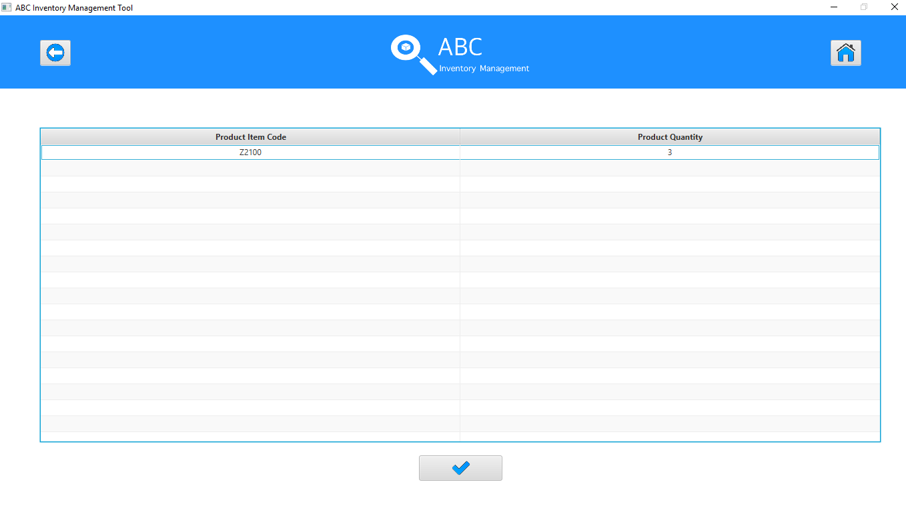

**Step 12**

After the user clicks on the ‘Accept’ button, the user updates the database and displays an appropriate message.

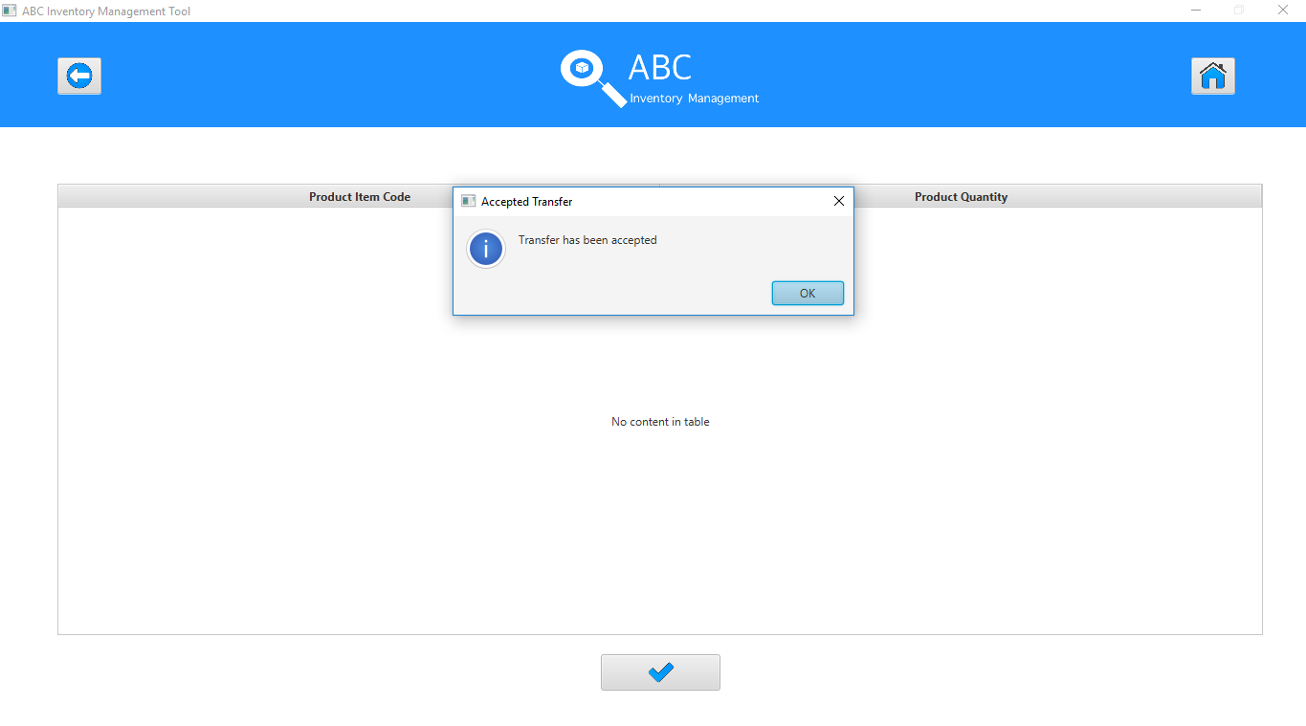

**Step 13**

When the user clicks on Ok, the system refreshes the accept product page.

